**DAILY ONLINE ACTIVITIES SUMMARY**

|  |  |  |  |  |
| --- | --- | --- | --- | --- |
| **Date:** | 16/07/2020 | **Name:** | JASLINE SHARON TAURO | |
| **Sem & Sec** | 4th sem,  A Section | **USN:** | 4AL18CS029 | |
| **Online Test Summary** | | | | |
| **Subject** | N/A | | | |
| **Max. Marks** | N/A | **Score** | N/A | |
| **Certification Course Summary** | | | | |
| **Course** | Data Scientist | | | |
| **Certificate Provider** | AWS | **Duration:** | | 3 hrs |
| **Coding Challenges** | | | | |
| **Problem Statement:**  Given an array, print the Next Greater Element (NGE) for every element. | | | | |
| **Status:** | | Executed | | |
| **Uploaded the report in GitHub** | | YES | | |
| **If yes Repository name** | | <https://github.com/jaslinesharontauro/JAVA_Prgms> | | |
| **Uploaded the report in slack** | | YES | | |

**CERTIFICATION COURSE DETAILS:**

## Today I started the new course“Data Scientist” by AWS. Today I learnt about big data analysis and architecture, visualization and streaming. I also completed the assignments of these two modules.

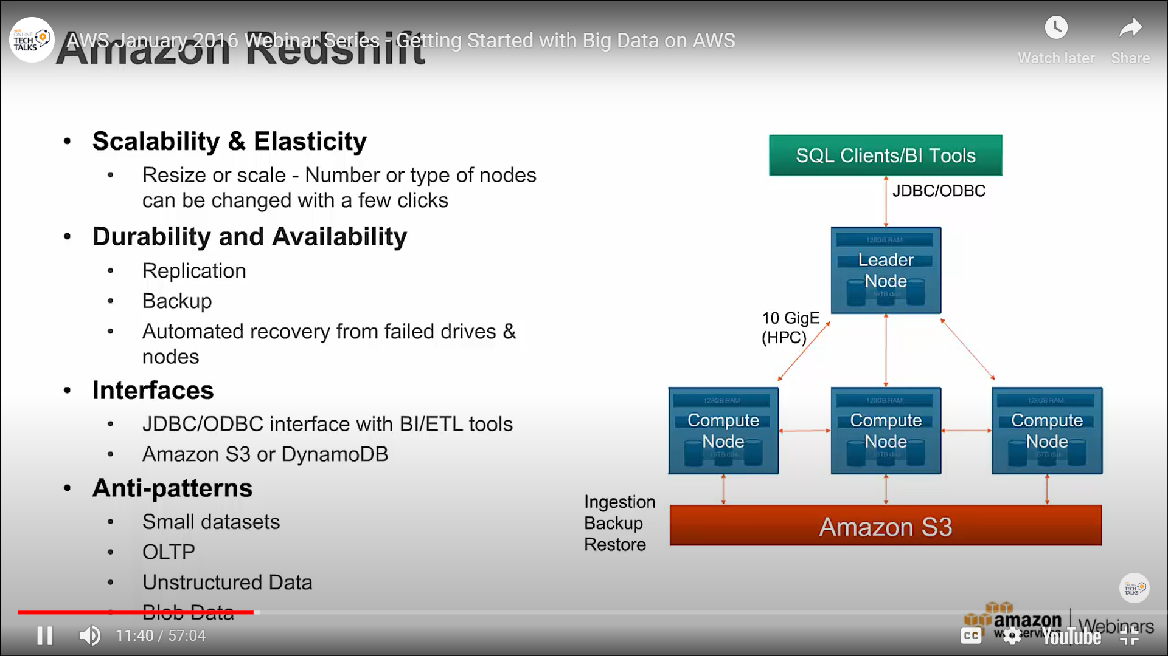

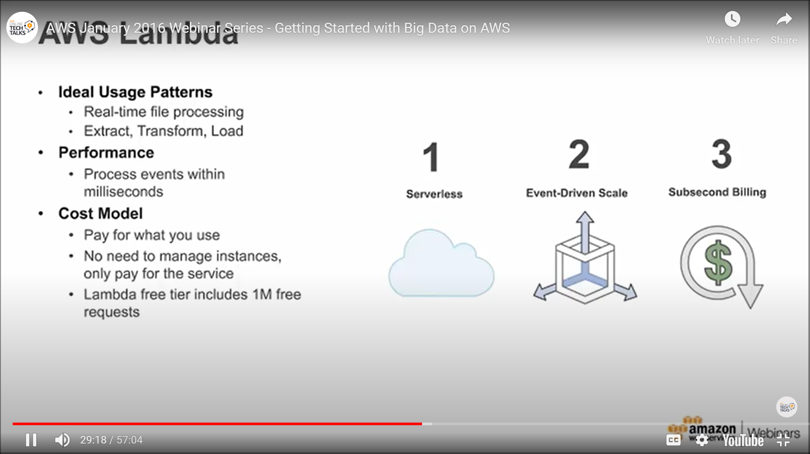

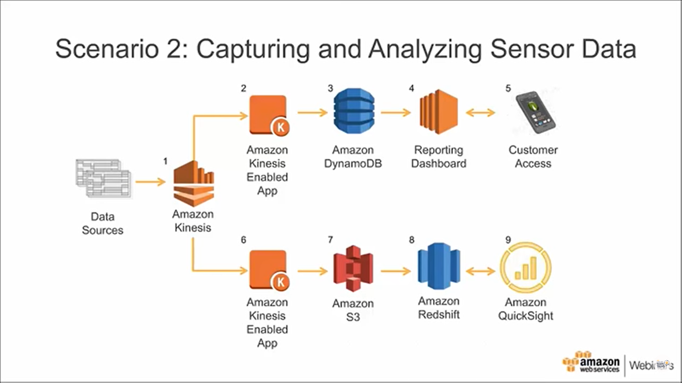

WEBINAR DETAILS:

Today we had webinar on “PROGRAMING IN C” by assistant professor Ms. Megha D. hedge-AIET. The session was very interesting.

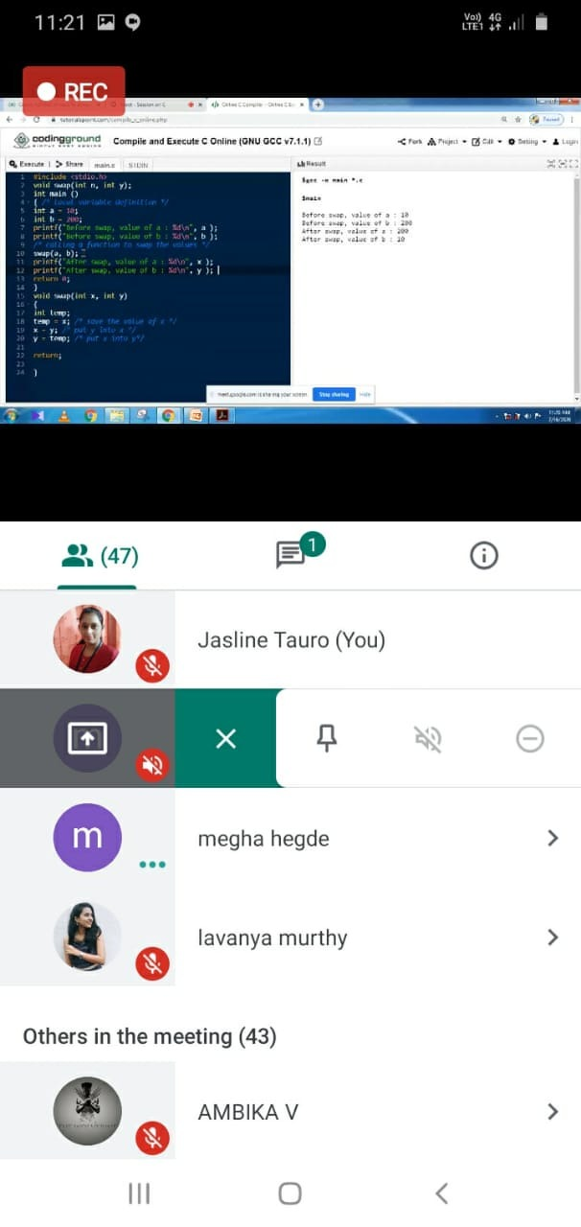

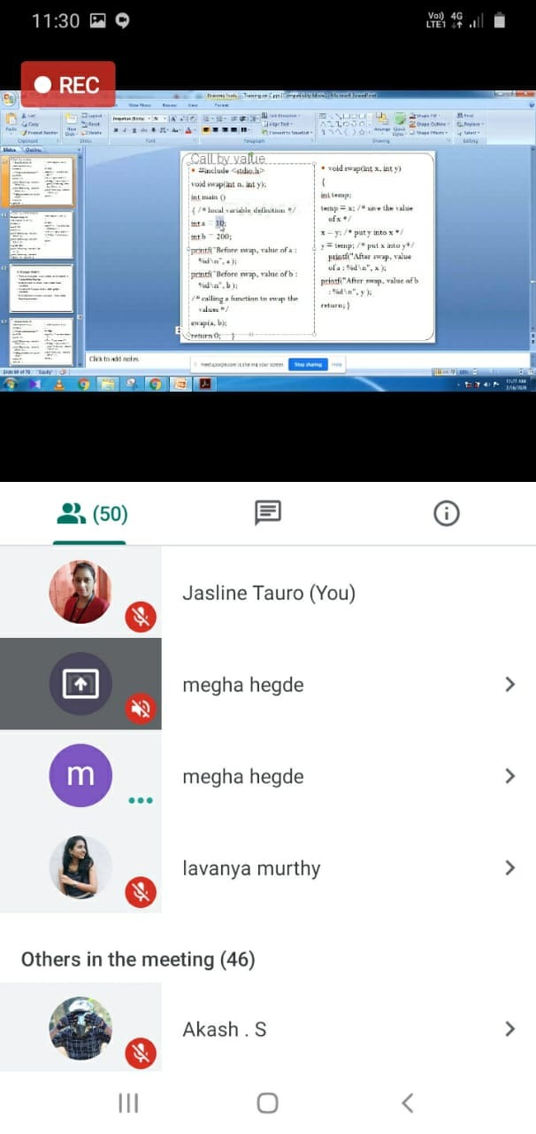

CODING CHALLENGES:

Problem Statement:

Next Greater Element

Given an array, print the Next Greater Element (NGE) for every element. The Next greater Element for an element x is the first greater element on the right side of x in array. Elements for which no greater element exist, consider next greater element as -1.

Examples:

For any array, rightmost element always has next greater element as -1.

For an array which is sorted in decreasing order, all elements have next greater element as -1.

For the input array [4, 5, 2, 25}, the next greater elements for each element are as follows.

Element NGE

4 --> 5

5 --> 25

2 --> 25

25 --> -1

d) For the input array [13, 7, 6, 12}, the next greater elements for each element are as follows.

Element NGE

13 --> -1

7 --> 12

6 --> 12

12 --> -1

Solution uploaded in GitHub

